**REAL-TIME DRIVER DROWSINESS DETECTION**

Prem kumar L1, Sadir Irfan2, Prashanth V3, Karthik Rathod4.

Guide: Shruthi M.L.J

Teaching Asst.: Deeksha H Kulal6

Department of Electronics and Communication Engineering.

PES University, Bangalore, Karnataka, India.

[Premmsagar1210@gmail.com](mailto:Premmsagar1210@gmail.com), [sadirirfan625@gmail.com](mailto:sadirirfan625@gmail.com) , [prashanthyadav1912@gmail.com,karthik.rathod.670@gmail.com](mailto:prashanthyadav1912@gmail.com,karthik.rathod.670@gmail.com)

**Abstract:** In the present era, where the roads are filled with vehicles all the time, accidents are prone to happen. Studies show that over 50% of these road accidents in a year, are due to driver drowsiness and fatigue. Many attempts have been made to develop a solution to this problem to detect when the driver is drowsy, but everything has its own set of limitations. Our project aims to solve this problem by detecting the drowsiness of the driver and sending an alert. We propose to use the Dlib Library to detect the driver’s face, and a number of landmarks are plotted on the entire face of the driver. Using these landmarks, various calculations and comparisons take place to check whether the drivers’ eyes are closed or open, and whether the driver is yawning or not. From this, the system determines whether the driver is drowsy or not. If the driver is found to be drowsy, an audio and visual alert is triggered to alert the driver. With this project, we aim to help the society by reducing road accidents, and saving lives and property.

**Keywords**: Eye Aspect Ratio, Eye Mouth Aspect ratio, Drowsy, Landmarks, Threshold.

1. INTRODUCTION

Road accidents are very common on Indian roads. A majority of these accidents are caused due to drowsiness and fatigue of the driver. One simple way of keeping a driver awake and alert is to engage them in frequent conversations. A report produced by the Ministry of Road and Highway in the year 2016 stated that at least 4,80,652 road accidents were reported in the country. In our project, we have proposed an approach that makes use of vision-based technology to detect the drowsiness of the driver. The major goals of our proposed system are (a) yawn detection, (b) creating a real-time response system, (c) detection of the eye (d) detection of the face, under a variety of conditions like with/without spectacles, with/without a face mask and under dim lighting, etc. The main focus of our project is to create a real-time drowsiness detection system that will be able to accurately and quickly monitor the state of the driver. Detection of fatigue depends on the state of eyes and yawn.

1. LITERATURE REVIEW

The authors have used CNN[1] to detect the drowsiness of the driver. The algorithm works by detecting the face and eyes of the driver using CNN[1]. The Adaboost algorithm[2] can also be used but DLIB is better in edge detection as it is sensitive to noise. By only checking the yawn analysis[3] we get little information of the state of the driver. Here the face is detected and from which the mouth region is extracted, which is fed to the algorithm as input. The analysis is done using SVM[3]. We can use the eye blink detection[4] using OpenCV to check the state of the author. This works by extracting the whole face and getting the position of the eyes individually and checking for the blink.

The existing system uses a camera to obtain a LIVE video feed, from which the user's face is detected[2] and the eye region is extracted. The Eye Aspect Ratio is then calculated. Then the threshold comparison takes place, from which it is classified whether the user is drowsy or non-drowsy.

1. METHODOLOGY

A video of the driver is captured using a camera, from which the driver’s face is detected. Once the face is detected, the eye region is extracted along with the mouth region. After the extraction of the eye and mouth regions, the Eye and Mouth Aspect Ratio (EMAR) is calculated, and then this calculation is compared with the threshold set and the user is classified as ‘Drowsy’ or ‘Non-Drowsy’. If the threshold is crossed, the driver is said to be in the ‘Drowsy’ state, and if the threshold is not crossed, the driver is said to be in the ‘non-drowsy’ state. If the driver is found to be ‘Drowsy’, audio and visual alerts will be sent to the driver to alert him/her.

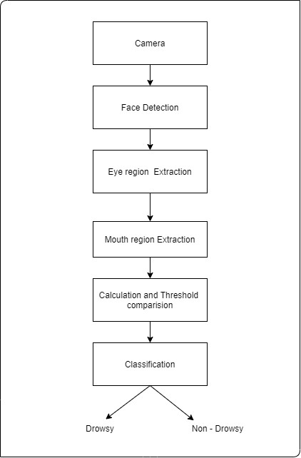

Figure 3.1: Proposed System

The different modules implemented in the application are:

1). Input Acquiring Module

2). Processing Modules

i). Extracts frames from the live video feed.

ii). Extract’s data points from the frames using DLIB.

iii). Analyses and calculates the data points, and compares the measure with the threshold.

3). User Alert Module

The project has 3 main modules, the input acquiring module, the processing module, and

the User alert module. The processing module is divided into 3 sub modules, the module to extract frames from the live video, the Module to extract data points/landmarks from each individual frame using the DLIB library, and the module for analyzing the data points along with calculation and comparison. The Input acquiring module is used to acquire the video of the user from the camera, which is then sent for processing. The 1st processing module fetches the video as the input from the input acquiring module, and this video is converted into frames. Each of the frames is then sent to the next module. On getting the frames, the 2nd processing module, with the help of the DLIB library, the landmarks get plotted. After this, the eye and mouth landmarks are extracted. In the final processing module, the analysis and calculation of the data points are done. The eye and mouth aspect ratio is calculated and this calculation is compared with the threshold set to check if the driver is drowsy or not. The final module is the user alert module, where if the driver is found drowsy, a warning is triggered in audio and visual form, which will be sent to alert the driver.

The general procedure of the real-time drowsiness/sleepiness detection algorithm in our project is fairly straightforward.

Initially, the camera is set-up which takes in the video frames as the input which includes the region of interest, the face.

Once the face is found, the algorithm applies 68 landmarks on the facial region and the eye and mouth landmarks are extracted. For the detection of facial landmarks, the Dlib library is used.

With the mouth and eyes landmarks found, the eyes and mouth aspect ratio is calculated to check if the eyes and mouth are opened or closed.

If the ratio calculation specifies that the eyes of the driver have been closed for a long period of time or if the driver is yawning for a long duration, an alarm is triggered to alert the driver.

If the eyes of the driver are closed for a long period of time, the ratio calculated will endure as it is. When the eyes are open, the ratio increases and vice-versa.

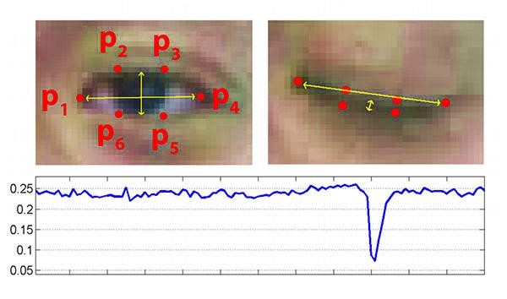

Figure 3.2: Eye landmarks and Eye Aspect Ratio Graph

The first image of Fig 3.3 shows an image of eye that is fully open with facial landmarks plotted on it. The second image of Fig 3.2 shows an image of eye that is closed. The third image of Fig 3.3 which is present in the bottom represents the graph of EAR when the eye is open and closed, we can observe that EAR is constant at the beginning (showing that the eye is open), then suddenly drops below threshold and comes up again showing that the user has blinked. In our project, we will continuously monitor value of EAR, if the EAR value drops below a certain threshold and does not rise back within 2 seconds then we classify the user to be drowsy and trigger an alert.

Out of the 68 landmarks mapped on the entire face, 6 landmarks are mapped for each eye. The left eye has landmarks 43-48, and the right eye has landmarks 37-42 assigned to them. The mouth has 20 landmarks mapped to it, which are landmarks 49-68.

The threshold of ratio for the closed eye is around 0.145, and for better results, the threshold of ratio in this methodology is set to 0.2. The formula for calculating the Eye Aspect Ratio (EAR) is,

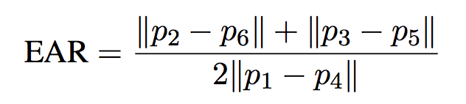

Where, x represents the distance between the lower and upper eyelids, that is, the average distance of points (p2,p6) and (p3,p5), and y is the horizontal distance between points p1 and p4. This can be seen in figure 3.3.

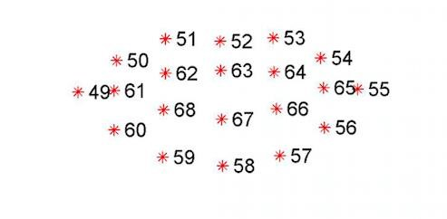

Figure 3.3: Landmarks plotted on mouth

For the mouth, landmarks 63 and 67 are taken into consideration. The distance between points 63 and 67 is calculated using the formula,

𝐷𝑖𝑠𝑡𝑎𝑛𝑐𝑒 = 𝑦2 − 𝑦1

Where y2 is landmark 63 from the upper lip, and y1 is landmark 67 from the lower lip.

When the Eye Aspect Ratio (EAR) crosses a set threshold for more than 10 frames, the user is considered to be ‘Sleeping’. If the distance between the lower lip and upper lip increases greater than 20 units, for more than 20 frames, the user is then considered to be ‘Drowsy’. The reaction time for the system is about 0.33 seconds.

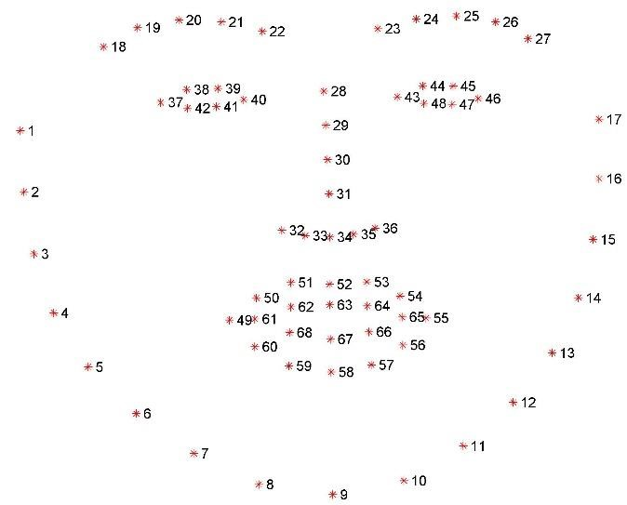

**Figure 3.4: The 68 Landmarks plotted on the entire face**

1. RESULTS:

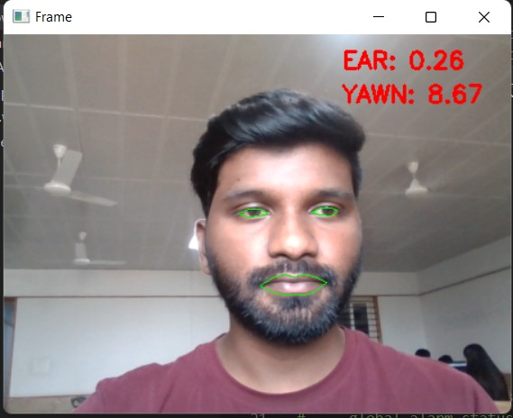

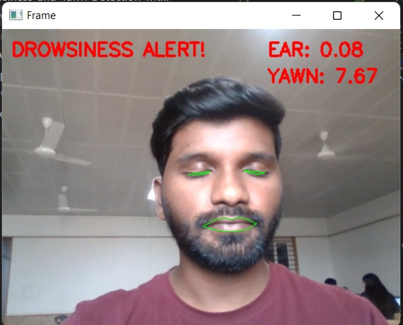

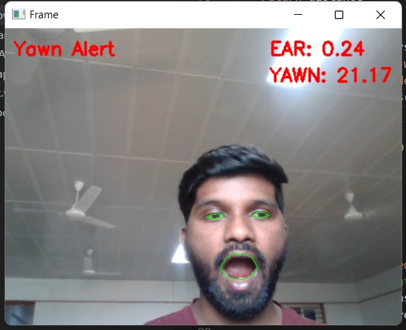

1. CONCLUSION

World Health Organization (WHO) claims that death occurring as a result of road accidents fall under the top 10 categories of causes of death. Driver sleepiness/ drowsiness detection plays an important role in safe and cautious driving. Driver sleepiness/ drowsiness detection is a cutting-edge technology that helps in preventing road accidents, which occur when the driver feels sleepy or drowsy. Reports and studies have found that 20 percent of the overall road accidents are due to drivers being fatigued or drowsy. We have proposed a system that will be able to alert drivers when he dowses off, which in turn will avoid accidents. The system detects the driver's face, and depending on the driver’s facial state, the driver is classified as drowsy or non-drowsy. If the driver is found drowsy, an alert is triggered in audio and visual form.

REFERENCES

[1]. L. D. S. Cueva and J. Cordero, "Advanced Driver Assistance System for the drowsiness detection using facial landmarks," 2020 15th Iberian Conference on Information Systems and Technologies (CISTI), 2020, pp. 1-4, doi: 10.23919/CISTI49556.2020.9140893.

[2]. M. Hedi Baccour, F. Driewer, T. Schäck and E. Kasneci, "Camera-based Driver Drowsiness State Classification Using Logistic Regression Models," 2020 IEEE International Conference on Systems, Man, and Cybernetics (SMC), 2020, pp. 1-8, doi: 10.1109/SMC42975.2020.9282918.

[3]. M. Z. Jafari Yazdi and M. Soryani, "Driver Drowsiness Detection by Yawn Identification Based on Depth Information and Active Contour Model," 2019 2nd International Conference on Intelligent Computing, Instrumentation and Control Technologies (ICICICT), 2019, pp. 1522-1526, doi: 10.1109/ICICICT46008.2019.8993385.

[4]. M. Dreißig, M. H. Baccour, T. Schäck and E. Kasneci, "Driver Drowsiness Classification Based on Eye Blink and Head Movement Features Using the k-NN Algorithm," 2020 IEEE Symposium Series on Computational Intelligence (SSCI), 2020, pp. 889-896, doi: 10.1109/SSCI47803.2020.9308133.

[5]. H. Oishi, H. Kawanaka and K. Oguri, "Effectiveness of Data Screening for Driver Drowsiness Estimation Using Drive Recorder," 2021 IEEE 10th Global Conference on Consumer Electronics (GCCE), 2021, pp. 766-769, doi: 10.1109/GCCE53005.2021.9622071.

[6]. H. Garg, "Drowsiness Detection of a Driver using Conventional Computer Vision Application," 2020 International Conference on Power Electronics & IoT Applications in Renewable Energy and its Control (PARC), 2020, pp. 50-53, doi: 10.1109/PARC49193.2020.236556.

[7]. I. Girish, A. Kumar, A. Kumar and A. M, "Driver Fatigue Detection," 2020 IEEE 17th India Council International Conference (INDICON), 2020, pp. 1-6, doi: 10.1109/INDICON49873.2020.9342456.

[8]. A. M. Al-madani, A. T. Gaikwad, V. Mahale, Z. A. T. Ahmed and A. A. A. Shareef, "Real-time Driver Drowsiness Detection based on Eye Movement and Yawning using Facial Landmark," 2021 International Conference on Computer Communication and Informatics (ICCCI), 2021, pp. 1-4, doi: 10.1109/ICCCI50826.2021.9457005.

[9]. K. S. Sankaran, N. Vasudevan and V. Nagarajan, "Driver Drowsiness Detection using Percentage Eye Closure Method," 2020 International Conference on Communication and Signal Processing (ICCSP), 2020, pp. 1422-1425, doi: 10.1109/ICCSP48568.2020.9182059.

[10]. J. Baikerikar, V. Kavathekar, R. John, L. Peeyus, P. Dharmadhikari and N. Ghavate, "Drowsiness Detection for Drivers," 2021 International Conference on Advances in Computing, Communication, and Control (ICAC3), 2021, pp. 1-5, doi: 10.1109/ICAC353642.2021.9697257

.